South Bay Food Swap

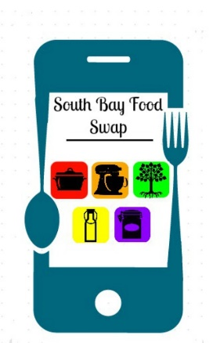

Please print and fill out this form (necessary to attend):

I am aware of the risks of participation, which include, but are not limited to, acquiring hand crafted goods not necessarily prepared in licensed kitchens or factories. I understand that participation in this event is strictly voluntary, and I freely chose to participate.

I, and my heirs, in consideration of my participation in the South Bay Food Swap, hereby release and hold harmless South Bay Food Swap and its founders and members, venues and any other people officially connected with this event, from any and all liability for damage to or loss of personal property, sickness or injury from whatever source, legal entanglements, imprisonment, death, or loss of money, which might occur while participating in this event. By participating in these events, you are also acknowledging that you will use the highest standards of safety and cleanliness in food preparation. (Food safety and food handling regulations within the United States can be found at: http://www.fsis.usda.gov/Fact_Sheets/Basics_for_Handling_Food_Safely/index.asp)

In signing this release, I acknowledge and represent that I have read the foregoing Release of Liability and Hold Harmless Agreement.

Name (sign)____________________________ Date______________

Name (print)___________________________